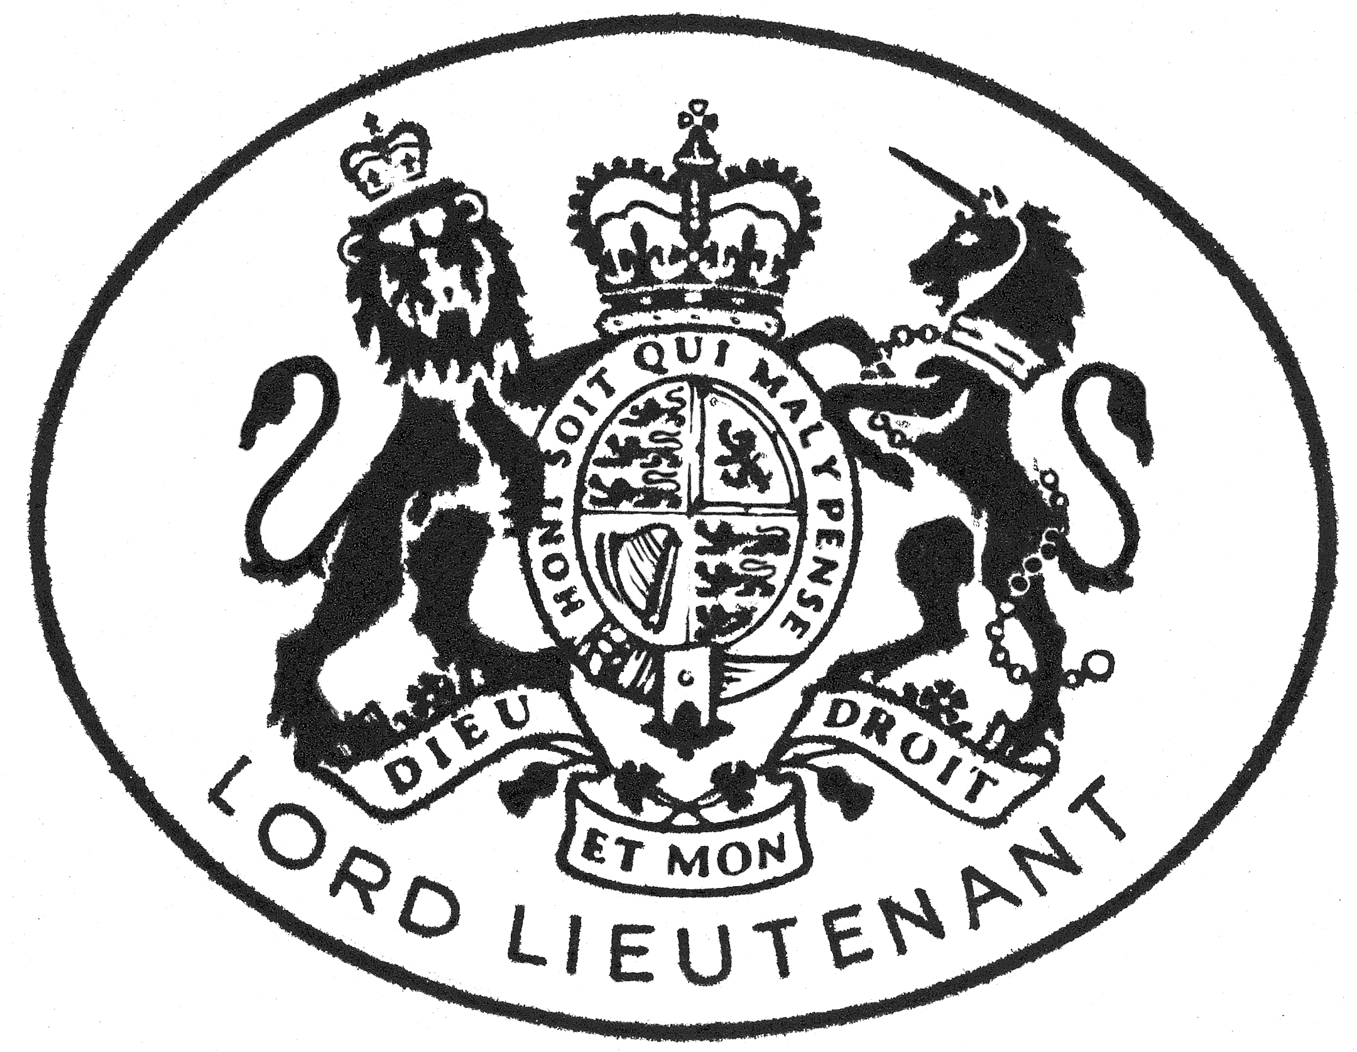

Guidance Notes for the Visit of the
Lord-Lieutenant or a Deputy Lieutenant

Introduction - Precedence, etiquette and protocol

The purpose of protocol is not to add unnecessary formality but to reduce confusion and ensure that people feel comfortable. The Lord-Lieutenant represents His Majesty The King. When the Lord-Lieutenant is attending an event in his official capacity in his own county, he should be received with the same degree of etiquette and protocol as any member of the Royal Family. Where the Lord-Lieutenant is unable to attend and he is represented by his Vice LordLieutenant or a Deputy Lieutenant, the same etiquette and protocol should be followed. The Lord-Lieutenant or his deputy should be met on arrival by the host.

The correct form of address for HM Lord-Lieutenant is as follows:

Written: Mr Alexander Scott, His Majesty’s Lord-Lieutenant
Salutation: Dear Lord-Lieutenant
In a Speech: In the preamble the Lord-Lieutenant should be referred to as "Lord-Lieutenant". A speech might begin "Lord-Lieutenant, Ladies and Gentlemen..."

If the Lord-Lieutenant is represented by his Vice Lord-Lieutenant or a Deputy Lieutenant, the above etiquette should be adapted accordingly i.e. ‘Dear Vice Lord-Lieutenant', ‘Dear Deputy Lieutenant'. A speech might begin "Vice Lord-Lieutenant, Ladies and Gentlemen..." or "Deputy Lieutenant..."

- The Invitation - It is helpful if the invitation makes clear whether or not the spouse is invited. It is also helpful to indicate whether or not the Vice Lord-Lieutenant or a Deputy Lieutenant would be welcome if the Lord-Lieutenant is unable to attend.

- Timings – It is helpful to indicate the expected time of arrival and departure.

3. Parking and Arrival – The Lord-Lieutenant appreciates directions to the venue, provision of a nearby parking space and someone allocated to greet and introduce her on arrival.

4. Dress – Specific guidance on dress saves any embarrassment and also helps the Lord-Lieutenant and his spouse plan the day. A Lord-Lieutenant has an official uniform and wears this on formal occasions when in attendance of or representing a member of the Royal Family. This dress is most appropriate for ceremonial military occasions, Remembrance Sunday, medals and presentations and attendances at parades that involve uniformed organisations.
The Lord-Lieutenant is more than willing to wear his formal dress if requested. It is simply a question of ensuring that it is appropriate to do so.

- Seating – As stated the Lord-Lieutenant is His Majesty the King’s representative in the County and it is appropriate to recognise this fact even though he might be attending an event at which others may be leading events. Thus, it would be correct that she and his wife would be seated or placed at an appropriate position in an audience or at a table.

- Speeches – The correct style and title is Mr Alexander Scott, His Majesty’s Lord-Lieutenant of Cumbria and thereafter the term Lord-Lieutenant is appropriate. In order of precedence he should be addressed before others who are present unless of course a member of the Royal Family is present. The Lord-Lieutenant is willing to speak if it is requested or is appropriate but only with notice beforehand. It will however, be especially appreciated if an appropriate brief can be prepared with as much background information as possible. It would always be better to err on the safe side and provide too much information rather than too little.

- Introductions – On first meeting it is appropriate to use the title and name but clearly this will depend on the formality of the occasion and how well known the individuals are. The Lord-Lieutenant will want to meet as many people as possible on any visit and will generally prefer it if whoever is looking after him and his spouse are proactive in introducing them, to meet as many people as possible. Introductions are greatly assisted with a brief outline of the individual’s post or position or activity within the event.

- Luncheons, Dinners etc – It will be helpful to provide details (whether a meal is involved or not) and to provide a running order of events stating who is involved and at what time. The Lord-Lieutenant is happy to propose the Loyal Toast as long as there are clear instructions on this.

- Security – If a member of the Royal Family is involved this will be dealt with by the Police in association with the Lord-Lieutenant’s Office. Otherwise no specific security arrangements are required.

- Gifts, Expenses etc – For the benefit of doubt there are no expenses involved in the visit of the Lord-Lieutenant as far as she personally is concerned. The Lord-Lieutenant would prefer not to receive gifts, especially at a charitable event nor would he want to attend a charitable function as a non-paying guest at the expense of the charity.

These notes are for guidance only and if you have any questions the Lieutenancy Office are always willing to provide guidance, help and clarity on the protocols of visits and the intention will always be to enhance the visit and make it as happy and enjoyable as is possible.

Lieutenancy Office

E: lieutenancy@cumbria.gov.uk T: 01228 221722

